**Basic plots with Matplotlib**

Hi! My name is Hugo, and I'm a data scientist and educator at DataCamp. I'm also the host of the weekly podcast DataFramed, which you need to check out to stay up to date with everything that's happening in data science. In this intermediate Python course, you're going to take your Python skills to the next level, specifically for data science.

You will learn how to visualize data and to store data in new data structures. Along the way, you will master control structures, which you will need to customize the flow of your scripts and algorithms. These are the types of things data scientists use every day. We'll finish this chapter with a case study, where you'll blend together everything you've learned to solve an exciting challenge.

**Data visualization**

This first chapter is about data visualization, which is a very important part of data analysis. First of all, you will use it to explore your dataset. The better you understand your data, the better you'll be able to extract insights. And once you've found those insights, again, you'll need visualization to be able to share your valuable insights with other people.

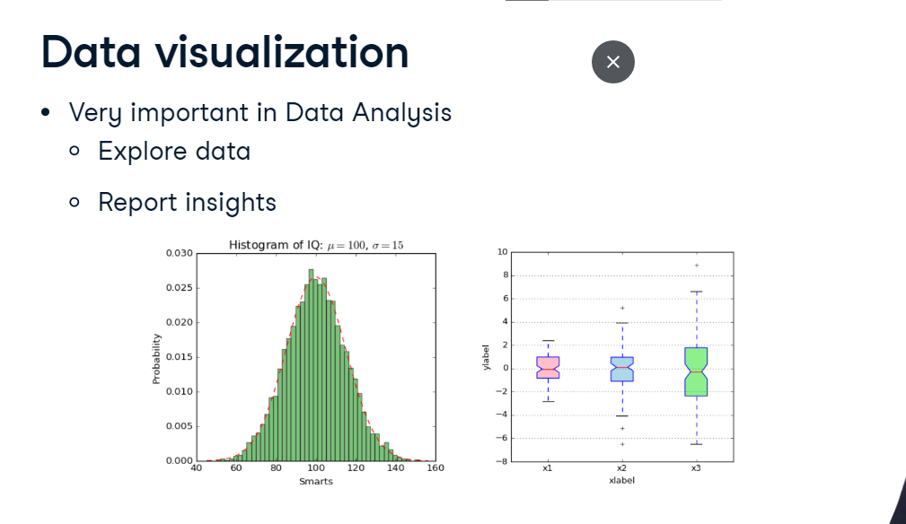

**Beautiful plot**

As an example, have a look at this beautiful plot. It's made by the late, the great Swedish professor Hans Rosling. His talks about global development have been viewed millions of times. And what makes them so intriguing, is that by making beautiful plots, he allows the data to tell their own story. Here we see a bubble chart, where each bubble represents a country. The bigger the bubble, the bigger the country's population, so the two biggest bubbles here are China and India. There are 2 axes.

1. 1 Source: GapMinder, Wealth and Health of Nations

**Beautiful plot**

The horizontal axis shows the GDP per capita, in US dollars.

1. 1 Source: GapMinder, Wealth and Health of Nations

The vertical axis shows life expectancy. We clearly see that people live longer in countries with a higher GDP per capita. Still, there is a huge difference in life expectancy between countries on the same income level. Now why am I telling you this? Well, because by the end of this chapter, you'll be able to build this beautiful plot yourself!

1. 1 Source: GapMinder, Wealth and Health of Nations

**Matplotlib**

There are many visualization packages in python, but the mother of them all, is matplotlib. You will need its subpackage pyplot. By convention, this subpackage is imported as plt, like this. For our first example, let's try to gain some insights in the evolution of the world population. I have a list with years here, year, and a list with corresponding populations, expressed in billions, pop. In the year 1970, for example, 3.7 billion people lived on planet Earth. To plot this data as a line chart, we call plt-dot-plot and use our two lists as arguments. The first argument corresponds to the horizontal axis, and the second one to the vertical axis. You might think that a plot will pop up right now, but Python's pretty lazy. It will wait for the show function to actually display the plot. This is because you might want to add some extra ingredients to your plot before actually displaying it, such as titles and label customizations. I'll talk about that some more later on. Just remember this: the plot function tells Python what to plot and how to plot it. show actually displays the plot.

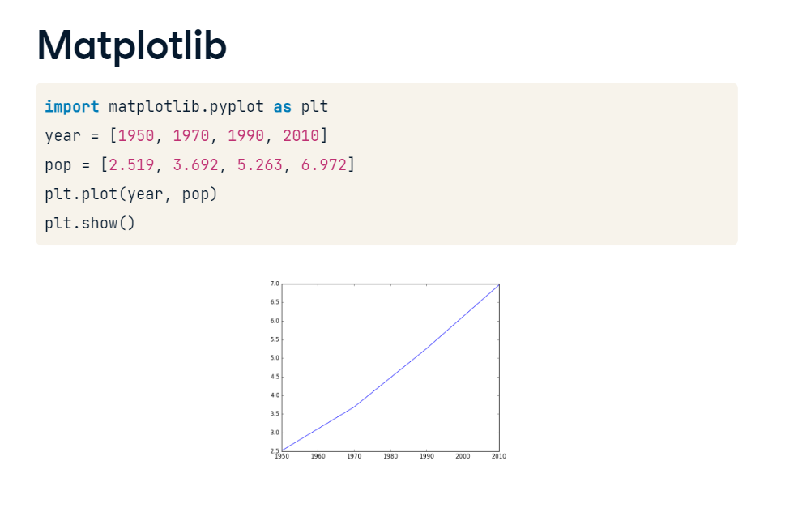

**Matplotlib**

When we look at our plot, we see that the years are indeed shown on the horizontal axis, and the populations on the vertical axis.

There are four data points, and Python draws a line between them. In 1950, the world population was around 2 point 5 billion. In 2010, it was around 7 billion. So the world population has almost tripled in sixty years. What if the population keeps on growing like that? Will the world become over populated? You'll find out in the exercises.

**Scatter plot**

Let me first introduce you to another type of plot: the scatter plot. To create it, we can start from the code from before. This time, though, you change the plot function to scatter.

The resulting scatter plot simply plots all the individual data points; Python doesn't connect the dots with a line. For many applications, the scatter plot is often a better choice than the line plot, so remember this scatter function well. You could also say that this is a more -honest- way of plotting your data, because you can clearly see that the plot is based on just four data points.

